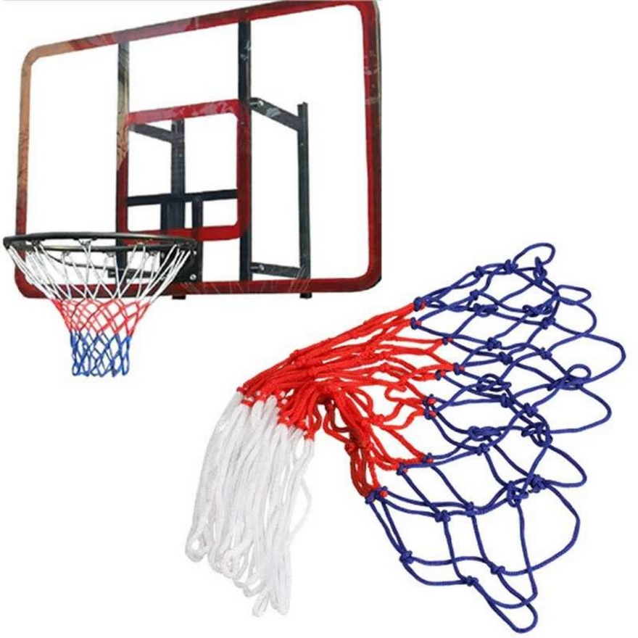

Standard Basket Ball Net

Rs. 149

~~Rs. 299~~-50%

* Premium Quality
* Long lasting & Durable
* Sturdy Construction
* Package Include Basket ball Net Only